Year 6 Pupil Work Pack 2020

NAME – ___________________________________________________________

PRIMARY SCHOOL - ______________________________________________________________________________

Hello,
We find ourselves in a very strange situation and I hope you are all keeping yourselves safe at home.
During your time at home I am sure you will be thinking about moving to secondary school and what next year is going to be like. It is normal to feel excited and anxious at the same time as well lots of other feelings.
Even though school isn’t fully open doesn’t mean we have forgotten about you, in fact we are even more excited about meeting you all as soon as we can. This is a great opportunity for you to spend some time reflecting on your primary school journey and begin to prepare yourself for joining us here at Studio West.
Please work your way through the activities in this booklet and when completed keep hold of it. We will ask you to bring it into school when you join us.
Keep an eye out on social media and your post as I will be regularly be sending out new information for both you and your parents. At the back of the booklet you will find an exciting initiative we will be launching soon and would love for you to get involved in.
Looking forward to seeing you soon,
Mrs Bell, Director of KS3 Learning
laura.bell@studiowest.newcastle.sch.uk

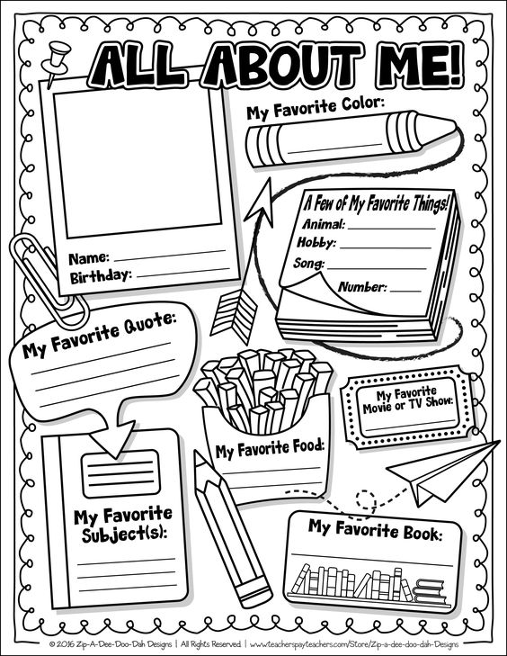

Our Ethos at Studio West
We have a strong family feel at Studio West and have some core beliefs that we talk about regularly. You will hear us talk about being ‘a part of our Studio family’ as a way of taking pride in our school.
In this box please write a paragraph about when you have made your family or friends proud and how it made them and you feel.

When have you worked hard? When have you proven there is no limit to your potential?
Draw a picture below and annotate (write around it) why you knew you had worked hard.
What are your biggest dreams in life?
When have you faced a really difficult challenge and not given up? How did this make you feel?
What subjects do you really enjoy? How can enjoying your learning help you to succeed?
Why is respecting others so important? How can your behaviour affect others?
Studio West School Rewards

At Studio West we love to recognise and award students who are embodying the Studio Ethos and striving to reach their potential. I know all of your primary schools will have wanted to reward you too and I am sure you all received recognition at some point.
Write about a time when you received a reward or recognition. What did you do to receive the award and how did it make you feel?
Fact Finding about Studio West School
Use the boxes below to write 5 questions you want answered about us. You could ask friends/ family who attend Studio West, use our website or our Facebook page.
Question 1 –
Question 2 -
Question 3 -
Question 4 -
Question 5 -

Answer 1 -
Answer 2 -
Answer 3 -
Answer 4 -
Answer 5 -

Getting Organised
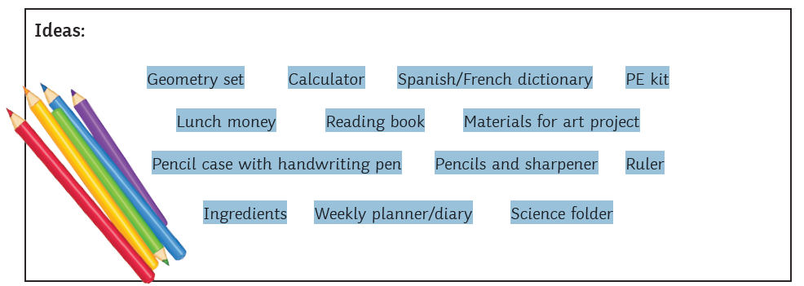
In secondary school you will need to follow a timetable and will have different lessons each day. You will need to be really organised to ensure you are prepared for each day.
Write below what you would need to pack in your bag to be prepared for this day.
Form Time  PE1 | Science  S1 | D.T (Food)  H1 | Lunch | P.E  Gym | English  E2 | Maths  M1

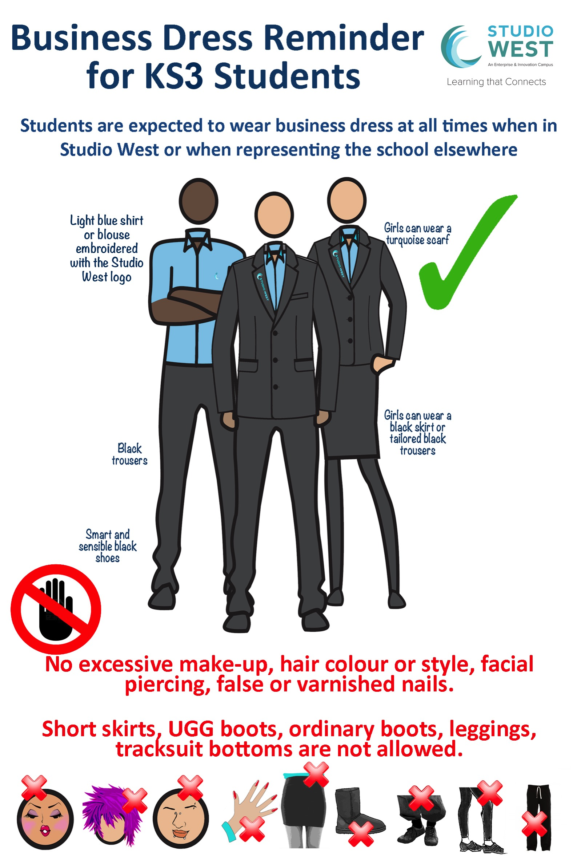
√
How does the Studio West School uniform differ from your Primary School uniform?

What are the pros (positives) and cons (negatives) to wearing a uniform?
Hopes and Aims for Secondary School
Secondary School is a new start for you. We believe you can achieve anything you want to achieve but this takes some planning!
Academic Hopes and Aims
In lessons I aim to _________________________________________________________________________________
__________________________________________________________________________________________________________________________________________________________________________________________________________

I hope to learn about ______________________________________________________________________________
__________________________________________________________________________________________________________________________________________________________________________________________________________

My Learning Goals are _____________________________________________________________________________
__________________________________________________________________________________________________________________________________________________________________________________________________________

Pastoral Hopes and Aims
I aim to make strong friendships because ________________________________________________________
__________________________________________________________________________________________________________________________________________________________________________________________________________

I hope to feel proud of myself when ______________________________________________________________
__________________________________________________________________________________________________________________________________________________________________________________________________________

I aim to be confident about _______________________________________________________________________
__________________________________________________________________________________________________________________________________________________________________________________________________________

Secondary School Scenarios – How will you deal with these situations?

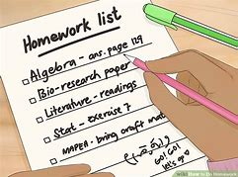
You walk up the Avenue for your first D.T lesson and you get lost.
What could you do?

Who could you ask?

How could you prevent this from happening?
You have been given a piece of homework that you do not understand how to complete.
What could you do?

Who could you ask?

What might happen if you didn’t ask for help?
It’s your P.E lesson and you have forgotten your Kit.
How might you feel?

What might you say? Tell me about what might happen.

What could you do? Who could you ask for help?

What might help you remember for next time?

Your Team Top Trumps:
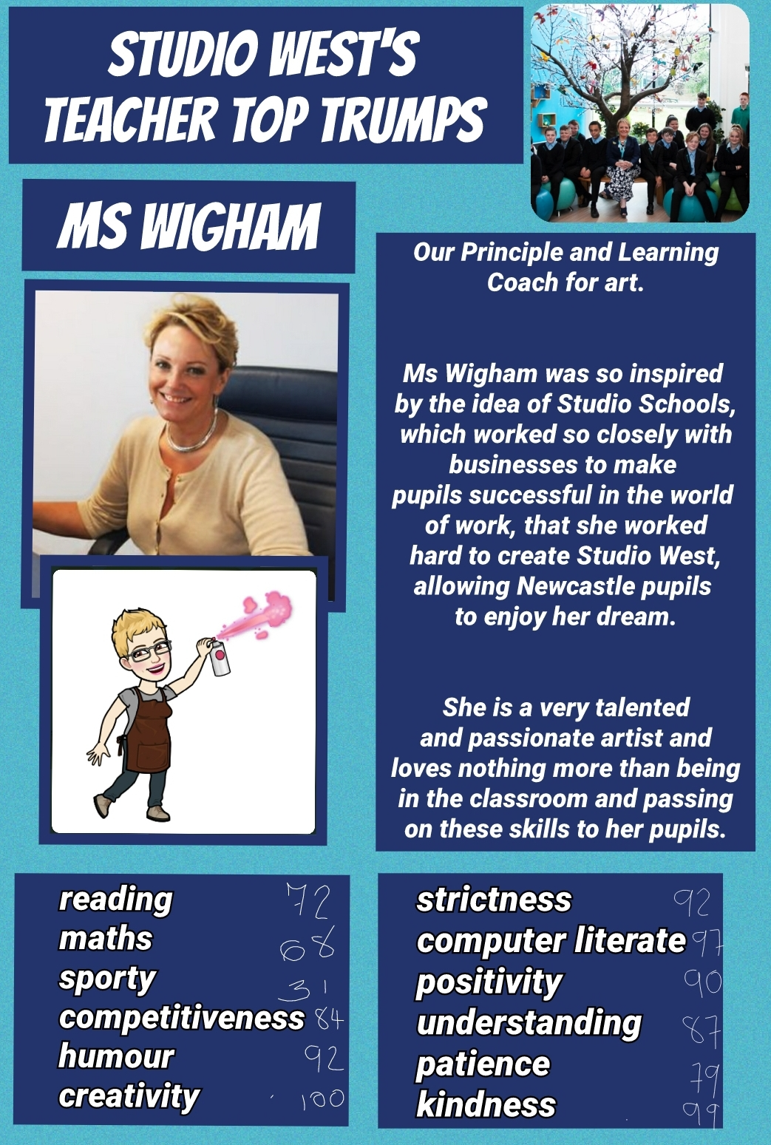 | 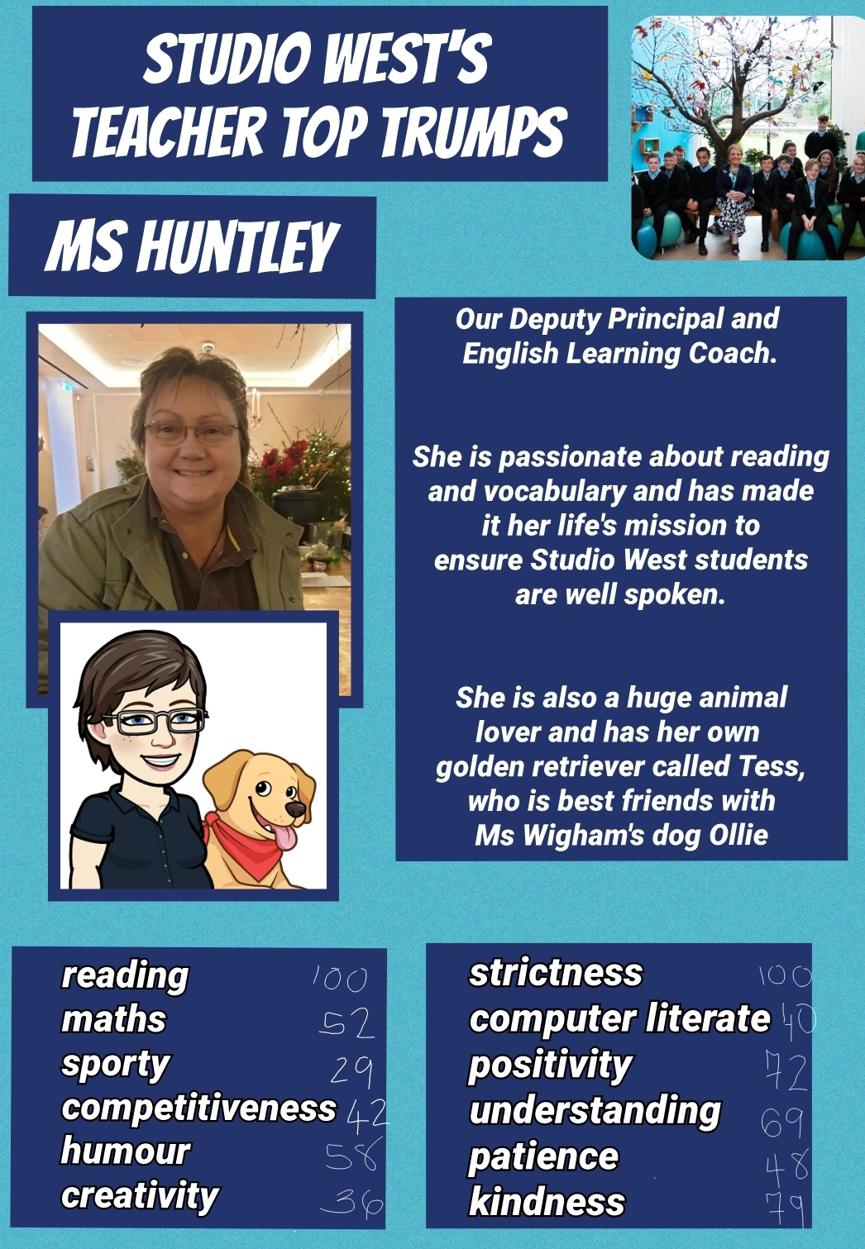 | 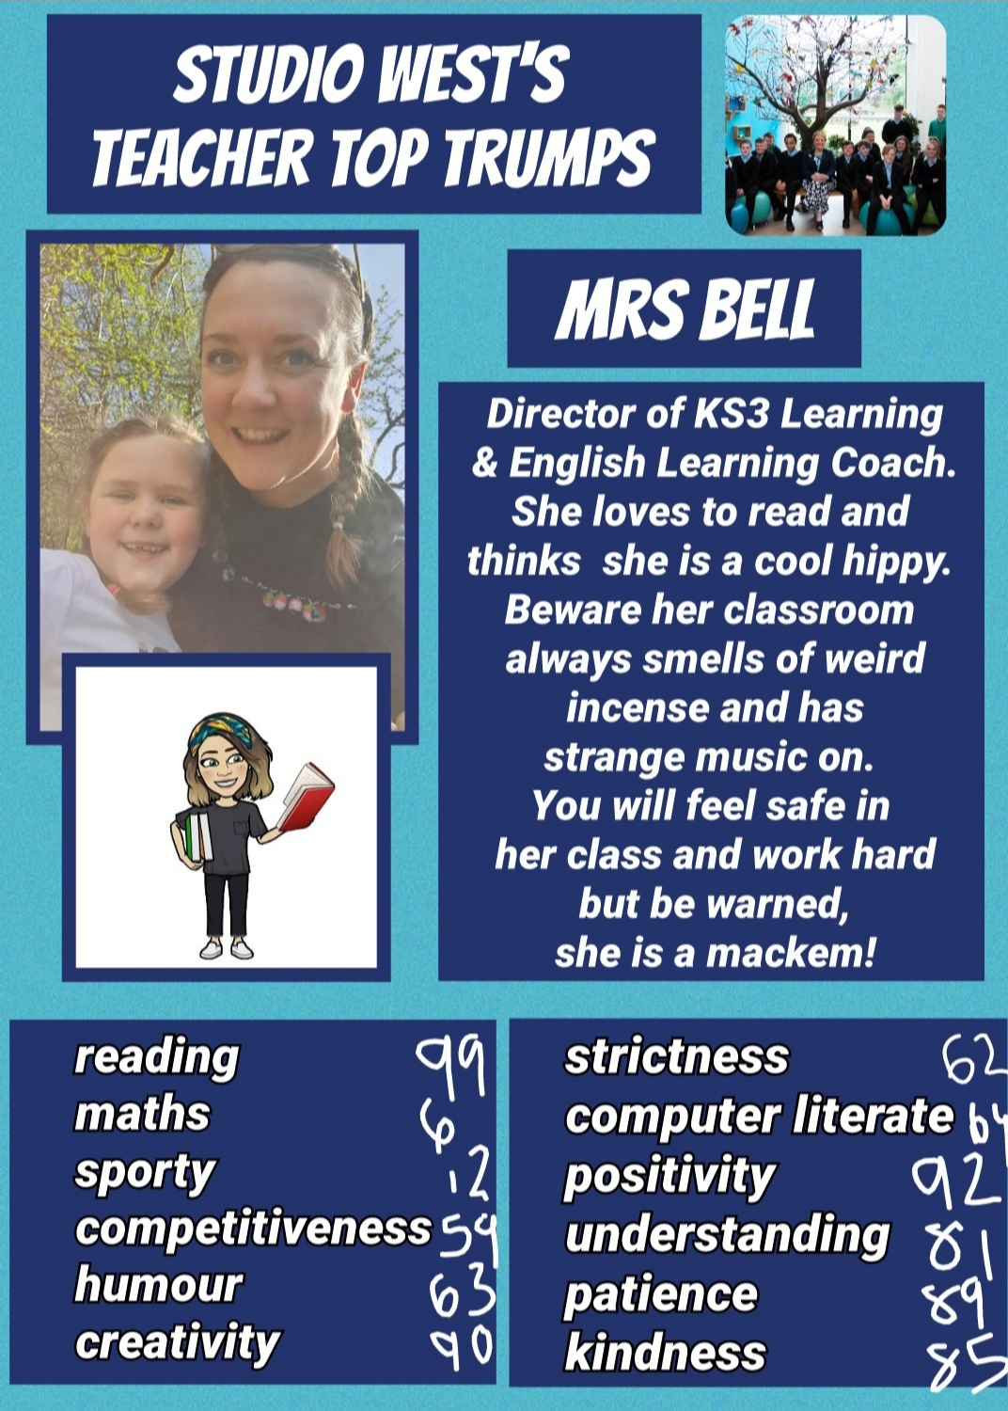
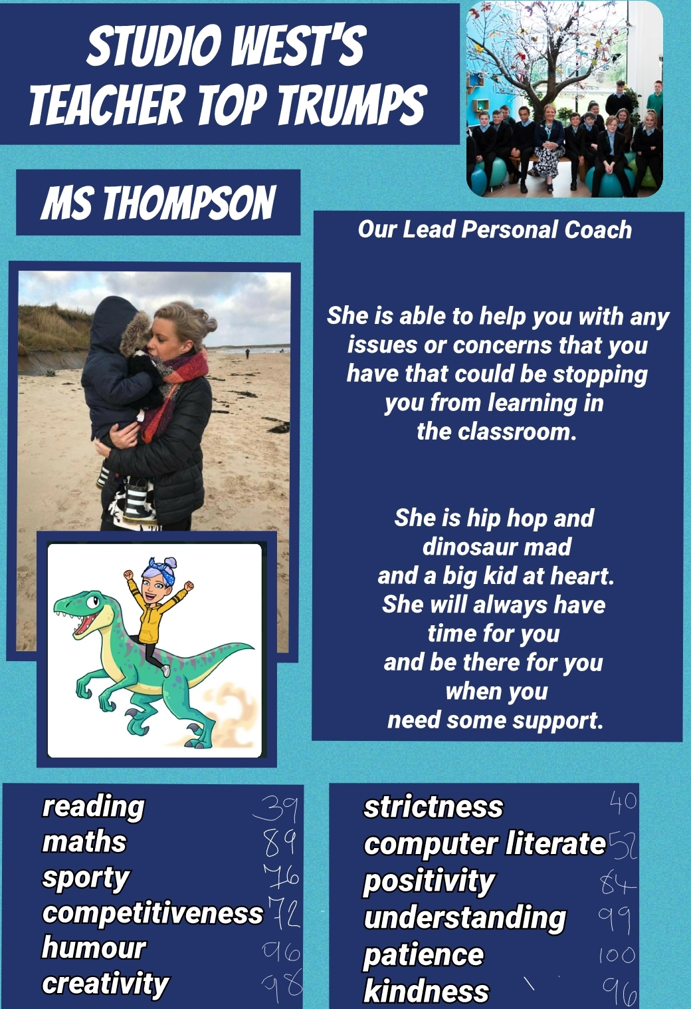 | 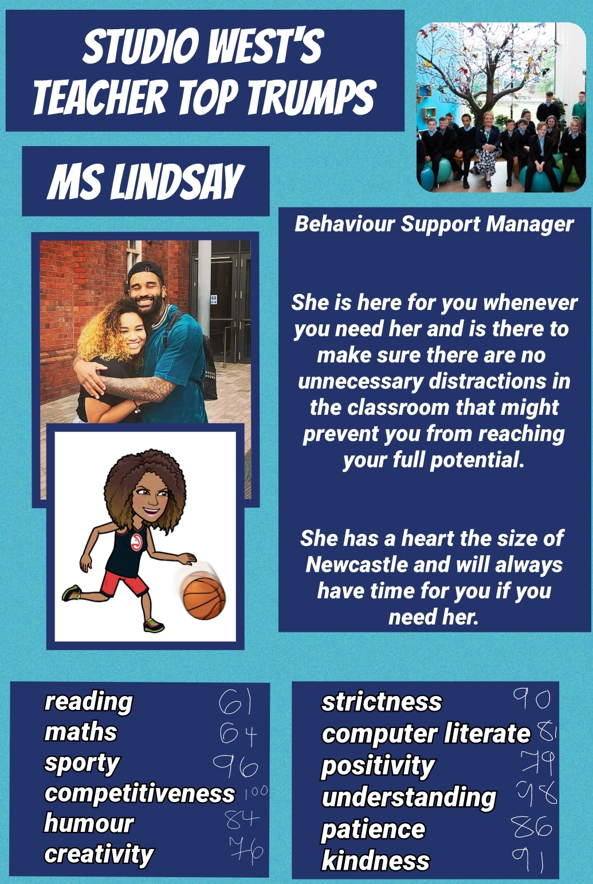 | 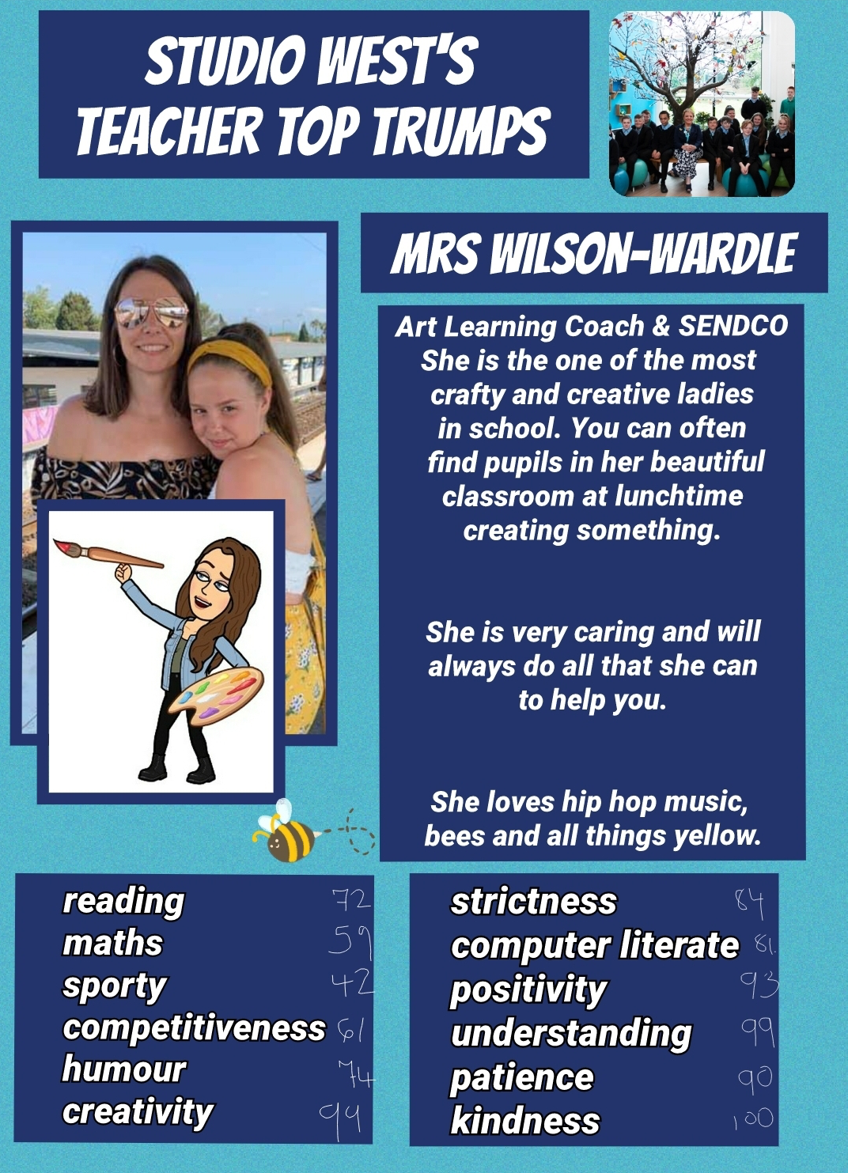

How can you get involved?
As I said at the start of the booklet, we are so excited about our new year group joining us and eager to start chatting with you. We would like you to ask us some questions you may have about joining Studio West. You can do this by clicking on the form below to get in touch:
https://forms.office.com/Pages/ResponsePage.aspx?id=pX0Jcsl1XE2dzBedkfqYuujKtjU7nVNIpCksW47NRPdUMFZXWlY2UzVVUTRCTE1DOVcxTVdTMTdPUC4u

