4th June 2020

Dear Parent/Guardian
We are writing to inform you about the changes to the PE kit for this coming September 2020. Following feedback from the students about the current kit and how they felt it was dated and needed to be modernised, we have been able to introduce kit similar to what we, as staff, wear. We are hoping this will make the children feel more confident and proud to wear their PE kit.
There have been some slight changes to what students can wear. Students participating in core PE will wear a navy blue polo top whereas students who have taken BTEC sport as an option will wear a royal blue polo top. In addition to this we have opted to supply additional kit for the students who represent the school teams in extra-curricular sport. This has come in the form of a reversible rugby top. This is not compulsory but it would help immensely if you play for a team. Furthermore, these tops are great in the winter months so are still available for core pe if you wanted to use them instead. Last year’s shorts and socks are still available to buy as usual and are still part of the current uniform.
When it comes to ordering this there will be a box to tick on the website. We have attached below what the kit looks like and the price and size guide.
We fully understand that some people may not have been planning to buy new kit this year therefore it is acceptable for the students to still wear their old kit as this transitions and hopefully by the start of the school year in September 2021 the whole school will present in the new style of kit.
The process of buying the kit is the same as previous years and it will be supplied by the same company, Top Class Uniforms. As usual you will be able to buy the kit as and when you need, for example, you may just want to buy the t-shirt and shorts for now and then buy the bottoms and zip top in addition for the rest of the year.
Throughout this lock down we have utilised the Teams app so if you have any questions please contact us either Mr Fawcett or Mrs Hurst.
Kind Regards
The PE Department
Anthony.fawcett@studiowest.newcastle.sch.uk
Stacey.hurst@studiowest.newcastle.sch.uk

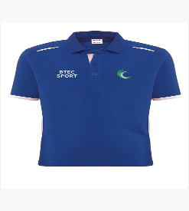
BTEC Sport Polo Shirt
Up to size 34’-36’ chest - £11
38’- 40’ and above - £13
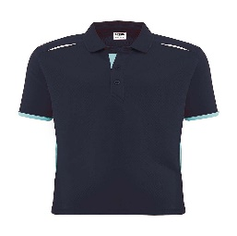
Core Sport Polo Shirt
Up to size 34’-36’ chest - £11
38’- 40’ and above - £13

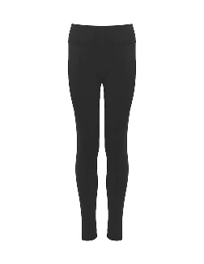
Core PE Leggings
Up to size 28’-30’ waist - £11
30’- 32’ and above - £13

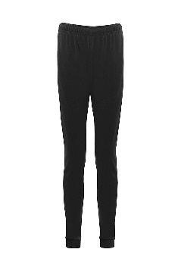
Core PE Bottoms
Up to size 28’-30’ waist - £11
30’- 32’ and above - £13

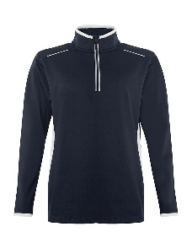
Core PE Zip Top
Up to size 34’-36’ chest - £18
38’- 40’ and above - £22

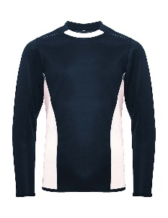
Extra-Curricular Reversible Rugby Top
Up to size 34’-36’ chest - £11
38’- 40’ and above - £13

